**Guidelines for Special Issues**

Dr. Hui Yang, Editor-in-Chief

November 7, 2023

# 1. Special Issue proposal

**IISE Transactions on Healthcare Systems Engineering** aims to foster the healthcare systems community by publishing high-quality papers that have a strong methodological focus and direct applicability to healthcare systems. Published quarterly, the journal supports research that explores: healthcare operations management, medical decision making, socio-technical systems analysis related to healthcare, quality engineering, healthcare informatics, healthcare policy.

We welcome and encourage special issue proposals to promote new areas in Healthcare Systems Engineering, increase the engagement of healthcare research communities, nurture a broad base of authorship, readership and partnership. Please see the guidelines to propose a special issue as follows:

* The special issue is recommended to include a leading guest editor, an editor (either DE or AE) from **IISE Transactions on Healthcare Systems Engineering**, and 2+ co-editors who are domain experts in the proposed area.
* Guest Editors (GEs) of the special issue should be experienced scholars and have an established publication record in top journals, e.g., peer-reviewed journals from IISE, INFORMS, IEEE, ASME, human factors, medical decision making, or healthcare communities.
* The leading guest editor should discuss the special issue proposal with the EIC to have an initial evaluation. After the EIC invitation, the leading editor can work with co-editors to develop a proposal. The special issue proposal should be submitted to IISE THSE Editor-in-Chief via email ([huiyang@psu.edu](mailto:huiyang@psu.edu)).
  + A template of the special issue proposal is available at this link: <https://csmmclab.github.io/IISETHSE/Template-Proposal-for-special-issue-IISE-HSE.docx>
  + An example of the special issue CFP is available at this link: <https://csmmclab.github.io/IISETHSE/SampleCFP-for-special-issue-IISE-HSE.pdf>
* The proposal will be reviewed and evaluated by both the EIC and the board of DEs for final decision. The evaluation criteria include: the scope and relevance of proposed topics, the innovation and broad impact on healthcare systems community, the qualification of guest editorial board, and the schedule of journal publication.

# 2. Publicity

Guest editors (GEs) are recommended to broadly disseminate the call-for-papers (CFP) and attract a significant number of high-quality submissions to their special issues worldwide:

1. The call-for-papers (CFP) should be announced on the conference website to inform potential authors about topic of interests in this special issue;
2. The emailing of call-for-papers (CFP) should be delivered to targeted email lists (e.g., INFORMS, IISE, IEEE), workshops, social media channels, and professional networks;
3. The GEs may send the CFPs to prospective authors and encourage them to contribute either as authors or reviewers;
4. The GEs should actively and broadly promote their special issue so as to receive a large number of paper submissions.

The IISE THSE Editorial Office will work with GEs to disseminate the announcement of Special Issues via the journal website, social media and IISE professional networks.

# 3. Paper review

* As shown in Figure 1, the EIC will review those papers submitted to the special issue and then assign to Guest editors (GEs), who will be granted short-term access to the Manuscript system during the period of their special issue.
* All GEs will be able to access the manuscripts, assign reviewers, handle revisions, evaluate review reports, and make recommendations to EIC. EIC and GEs will conduct the two-stage desk review to filter out low-quality papers with problematic issues as follows:
  + topic not fit,
  + incorrect format,
  + poor writing
  + plagiarism
  + insufficient novelty
  + unclear contributions
  + Missing files.
* GEs should follow the timeline proposed for their special issue. If an extension is needed, GEs must consult with the EIC for approval before publicly announcing the extension.
* All submissions must be peer-reviewed by at least three (3) independent reviewers. To reduce the review lead time, the GEs should frequently check the status of each submission and make sure there are a sufficient number (≥3) of high-quality reviews returned before the deadline.
* GEs should evaluate the review reports and make their recommendation to the EIC.
* The EIC will take recommendations from the GEs and then make the final decision. A decision letter and review reports will be sent to the authors. Authors of accepted submissions will be further handled by T&F editing process.

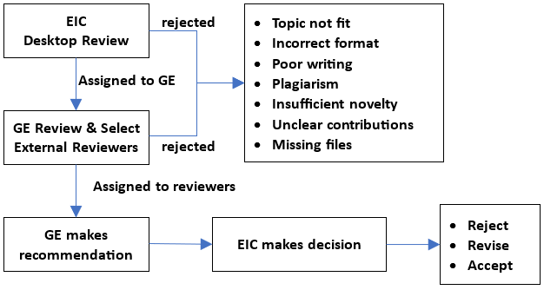

Figure 1: The workflow of special issue reviewing process

# 4. Additional notes for guest editors

* Guest editors are required to uphold the quality standard for the special issue.
* Guest editors should prepare an editorial for the special issue.
* Guest editors are discouraged from submitting to the special issue that they are editing to avoid Conflict-of-Interest (COI).
* If, under specific circumstances, a guest editor submits his/her paper to the special issue, it will be directly handled through the IISE THSE Editorial Office.

If you have any questions, please do not hesitate to contact the Editor-In-Chief of IISE THSE via email ([huiyang@psu.edu](mailto:huiyang@psu.edu)).